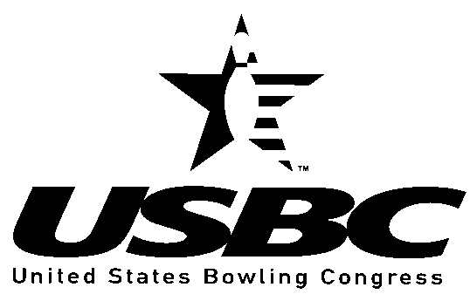

GREATER LAKE COUNTY USBC
Star of Tomorrow

Application

Scholarships:
The Greater Lake County USBC will award up to four scholarships to two boys and up to two girls in the amount of $1,000.00 each annually, provided the recipient meets the eligibility requirements and has submitted the proper Greater Lake County USBC Star of Tomorrow scholarship application and any other necessary attachments.

Eligibility:
- Candidates must be an amateur as defined by the United States Bowling Congress. Only those who have not bowled for money or merchandise prizes in accordance with USBC rule 400 are eligible.

- The applicant must bowl in a certified Greater Lake County USBC youth bowling league and must be between 14 and 18 years of age at the time of the deadline for consideration.

- Additional funds may be awarded to a boy or girl recipient at the discretion of the Greater Lake County USBC Youth Committee.

- Applicant must possess an accomplished bowling record and show potential for future success.

- Star of Tomorrow recipients are only eligible to receive one
scholarship award from the Greater Lake County USBC.

Applicant Information

Name _______________________________________________USBC #_______________________________________

Address

City, State, Zip

Telephone Number(s) ( )
( )

Date of Birth
Age as of June 1

Educational and Academic Information

List high school and/or college attendance.

Name City State Years Attended/Graduated

Name City State Years Attended/Graduated

Name City State Years Attended/Graduated

Current G.P.A. based on

Counselor Verification (required)

Name (please print)

Signature

List scholastic honors, extracurricular activities and community involvement.

Bowling Information

How long have you bowled in league?

List the bowling centers in which you have competed in the last year.

League Name Center City Final Average

League Name Center City Final Average

League Name Center City Final Average

List highest certified scores.

Game:
Series:

Highest certified average for 21 games or more
Year

Other Involvement

League special awards / tournament titles. etc.

PERSONAL STATEMENT (Required)

List three References. (Individuals who can comment on your bowling ability or general character).

 |  | ( )
Name | Address | Phone Number

 |  | ( )
Name | Address | Phone Number

 |  | ( )
Name | Address | Phone Number

Additionally
You may also submit up to three letters of recommendation with this application.

Return this application
and all additional information to:

Greater Lake County USBC
Youth Scholarship Committee
702 Ridgewood Drive

Antioch, IL 60002

Deadline for filing an application for consideration for the next Greater Lake County USBC

Star of Tomorrow Scholarship must be

POSTMARKED BY JUNE 1ST

All applications not selected for an award will be kept on file with the Greater Lake County USBC for three years. Each year the Greater Lake County USBC will notify those applicants on or around May 1, so they may update their application. It is the responsibility of the applicant to notify the Greater Lake County USBC if there is an address change by the applicant.

The Greater Lake County USBC reserves the right to accept or deny any application for Greater Lake County USBC Star of Tomorrow

